
The Sehgal Foundation

Sustainable Rural Water Management
A replicable case study

Lalit Sharma*, Jay Sehgal, Ellora Mubashir

The Sehgal Foundation, Gurgaon

Key words: silt management, check dam, soak pit, recharging wells, water quality, ground water recharge, hygiene, community involvement, sustainability, low cost innovations, village water management costs, small interventions to revitalize existing structures.

Abstract
This paper touches on key elements of sustainability pertaining to rural water management, but with greater focus on improving technical sustainability of the infrastructure, through innovations. Often the failure of water management structures is due to lack of design for silt management. Three important water management structures which cause high impact in a typical Indian village are check dams, recharging wells and soak pits. Additionally breaking the hard pan, formed in agricultural fields due to excessive use of fertilizers, by deep ploughing with chisel is also helpful in recharging. Low cost technical innovations were made in these structures vis á vis silt management for their long term sustainability. The case study is on integrated water management in village Ghaghas¹, Haryana, which is replicable in general, though micro conditions in villages would be different. Sehgal Foundation’s experience during implementation and the lessons learnt are expressed. It is realized that water management need not be too cost intensive or long drawn in terms of time, if certain principles are followed.

I. Introduction
Sehgal Foundation works on integrated and sustainable village development in Mewat region of Haryana. This goal is implemented through four programs (1) Water Management (2) Income Enhancement (3) Family Life Education (4) Rural Health, and the support services of Infrastructure Building and Communications. The approach is participatory and programs are organized around ‘Village Level Institutions’ and ‘Village Champions’.

The factors responsible for sustainability of any rural development project are - motivational, financial, organizational and technical.

Mewat is a region which falls partially in Haryana and in Rajasthan, with the Aravali hill range across it. Aravalis are the oldest hill range in India and have become mostly deunuded. The soil cover on the hills has been eroded and flora is found only in small patches, the rest being barren rock. During summer, dust storms from Rajasthan desert hit the Aravali hills resulting in sand dunes at the foot hills, which also adversely affect the flora. Underground sweet water is found only in the foothills of the Aravalis, otherwise it is mostly brackish.

Mewat takes its name from Meos, a muslim peasant caste that converted from Hinduism to Islam, however they preserve many Hindu customs. Agriculture and wage labour (30 % of population) is the dominant occupation. As many as 40 % households are landless and 40% have marginal land holdings. The agriculture is primarily rain-fed with mustard and pearl millet being the main crops. Mostly only one crop a year can be cultivated, due to water constraints, and a second crop is possible only if there are timely rains. The social indicators of Mewat are low, sex ratio being 865, literacy 19% with women literacy much lower, household size 8.4, age at marriage is 14 years for girls and 17 years for boys. The reproductive health of women is poor, there is low awareness regarding preventive health care and a high reliance on untrained health providers. Women are treated as unrecognized labor both in fields and domestically.

In Mewat region of Haryana, India, availability and quality of water is of primary concern. A tailor made, integrated water management plan is needed for each village, with the first step being the study of topography, water flow, soil characteristics and traditional knowledge. Subsequently, high impact interventions can be chosen. Sustainability of interventions is also a function of equity, as a critical mass of people will come together if all are going to be benefited.

In Ghaghas the quantity of available ground water was inadequate and fast depleting, its quality too was poor with high content of nitrates and fluorides. Since the ground water of Ghaghas is an important water source for several neighboring villages, they are also adversely affected. This scenario is now improved with the interventions.

As in many villages of India, here too the domestic waste water flows into the streets, creating dirty puddles which are a breeding ground for pathogens and their carriers. This water is a medium by which the ground water gets contaminated due to open defecation, open composting and excessive use of chemical fertilizers and pesticides in the agriculture.

To address the high nitrate and fluoride contents found in the drinking water, it was decided to work on the quality of the water at the source itself rather than use other solutions like filters or water treatments. The logic adopted was to dilute the ground water with rain water, so that the nitrate and fluoride concentration would reduce to acceptable standards and at the same time the ground water would be replenished.

In Ghaghas, a check dam was built at a location upstream so that the runoff water from the Aravali hills is not allowed to enter the village and get contaminated (Figure 1 and 2). A ridge to valley approach (Figure 3), was adopted by building gully plugs to slow down the speed of water, thereby reducing soil erosion and the silt load entering the dam. Other options, including diverting natural streams to recharging wells or injecting wells (Figures 4 and 5) are also an efficient way to add to ground water. Even dry wells are structurally well-connected to the underground water table, while much more effort is required to find other parts of the village where soil has good percolating ability right upto the water table.

Safe disposal of domestic waste water is addressed through soak pits, which are simple and cheap drainage structures facilitating the disposal, filtration and percolation of wastewater into the ground (Figure 6, 7).

II. Methodology
Working with the Community
As a first step, the requirements of the people are identified at community meetings followed by survey of the region together with some villagers, their knowledge is solicited, experts are brought in and Sehgal Foundation’s engineer works out a draft blueprint. The blueprint has details of design, material, time-lines and costs (Table 1), which is presented to the community. The villagers often modify it and also decide on what they can contribute, since some contribution from them is mandatory by the Foundation’s policy. In this whole process the Village Level Institution, Village Champion & Panchayat are involved.

Overcoming the Technical Challenge of Silting through Innovations
Check Dam
Each year, the sedimentation of the silt load brought by the rainwater runoff decreases the effective storage capacity of check dams and the percolation of water. Invariably removal of this silt from the storage basin is laborious and expensive, which the villagers are usually not motivated enough to do, leading to abandonment of such structures after some time.

In addition to the ridge to valley (Figure 3) approach which reduces the silt load reaching the check dam, a cheap technique for desilting has been introduced in the design of the check dam itself, by providing several outlets at its ground basin level (Figure 8 and 9). These desilting drains are closed on upstream side with a layer of brick masonry. In about 2-3 years, the villagers would need to plow the basin with the help of tractor before the first monsoon rain and break open the desilting drain openings.

In this region the distribution of monsoon rain is in intense spells with gaps in between. The first intense monsoon rain would force the loosened silt out of the check dam through the drains. During the dry spell between two showers these openings are to be closed with a layer of brick masonry like before, for water storage.

The silt which deposits outside the check dam is fertile soil and can be used in agricultural fields. It can be carried away by villagers easily in carts from this place, unlike if they had to carry the ploughed silt from the basin of the check dam.

Recharging Wells
In Ghaghas, there is a natural stream which runs through the village during monsoon and this water flows out without being used for recharging the ground water. Two minor interventions at an appropriate location have significantly reduced this waste (Figure 4 and 5). It was observed that the Government had earlier built three injecting wells near the stream but currently water from the stream was not reaching them, thus these useful structures have become redundant. Also there was an abandoned open well nearby.

A short masonry wall was built across the stream to force the water to collect on the side of the injecting wells, which now get submerged. The collected water is also directed to the abandoned well through an underground pipe after it passes through an inverted filter to reduce the silt load to the well. The swirling action of the high velocity stream water removes the silt load deposited on the surface of the inverted filters of the recharging and injecting wells, so they do not get blocked.

Soak Pits
Soak pits have been advocated by many organizations but their adoption in villages has not been satisfactory.

When Sehgal Foundation tried out the commonly promoted soak pit model it was found that within a short period the entire underground structure was getting clogged with debris, making it defunct. A sieve was introduced at the mouth of the pipe through which the waste water enters the soak pit. This too did not work, as it needed almost daily cleaning or would get clogged, and it was a particular problem in public places to get a cleaner.

The successful innovation was the introduction of a silt trap before the entry of the water into the soak pit (Figure 7). This design needs cleaning every 1-3 months of a small, easily accessible area. Soak pits are to be closed during the heavy monsoon rain when excessive silt can accumulate. After this innovation, the concept has become demand driven in several villages (Figure 6).

Studying the impact of recharging, on ground water quality
Two sampling sites were selected for this study at a distance of 150 meters (Site A) and 1500 meters (Site B) from the major source of intervention i.e. check dam (Figure 10, Table 3). Site A is a well and Site B a hand-pump. The baseline water testing was carried out in June 2003, before monsoon when the ground water table is at its lowest, and subsequently every quarter. The water testing is ongoing.

III. Results
The check dam has the capacity to receive run-off from about 2.75 square kilometer catchment area, which percolates about 100,000 kiloliters of water per annum. The fifty six soak pits of Ghaghas contribute 4,088 kiloliters into the ground. In Ghaghas, 60 acres of land was deep ploughed by chisel and contributed 135,000 kiloliters (4500 sq. meter x 0.5 average rainfall x 60) of water into the ground, per year.

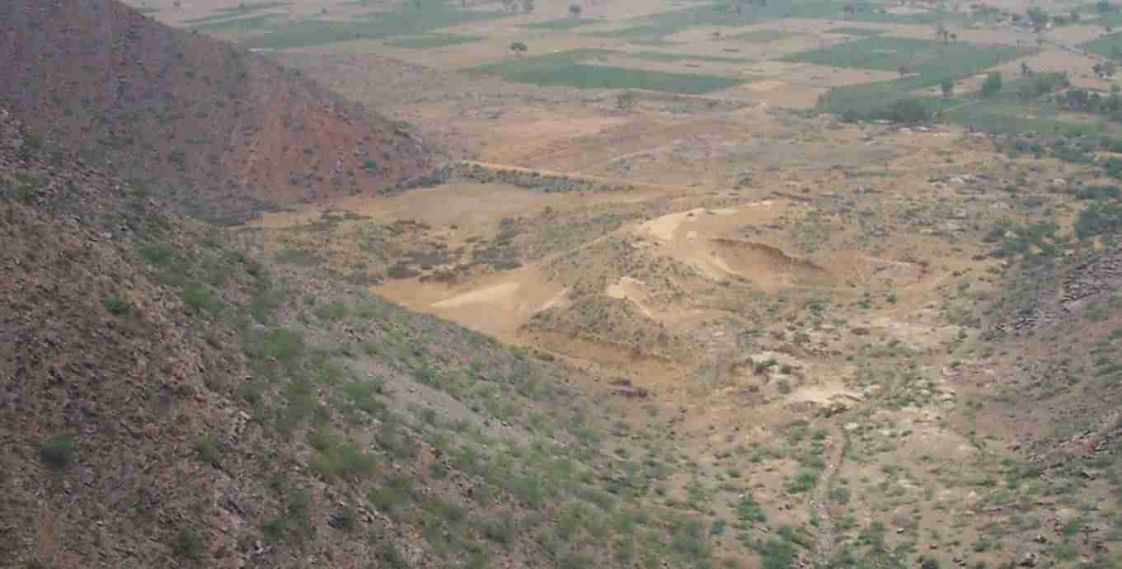
Figure 1: Integration of new structures with revived traditional ones
Traditional tank repaired
Check dam site
Village
Aravali Hills
Rain water Flow
Earthen Embankment
Rain water Flow
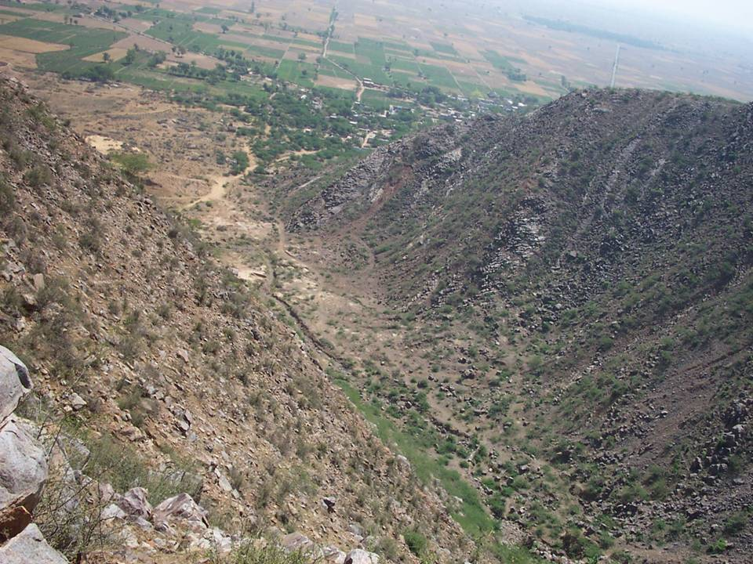
Check dam Site
Figure 2: Percolation of stream water before it gets contaminated
Ghaghas
Aravali Hills
To counter the contamination of ground water due to open defecation, the Foundation promotes several models of latrines which it has customized³ for different economic backgrounds of villagers, with a cost range from Rs. 500 to Rs. 3000.
Figure 3: Integrated Ridge to Valley Approach in Ghaghas
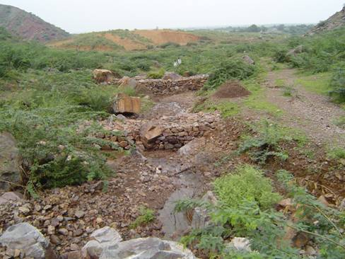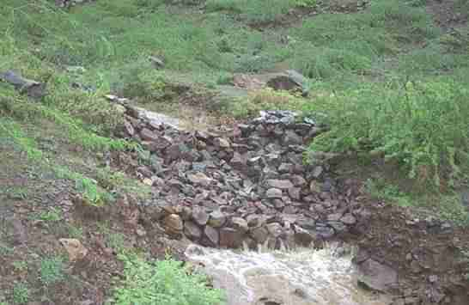
Gully plugs slow down the flow of
water, to percolate it and reduce silt load
to check dam
Last year 2003, the check dam resulted in almost 1 lakh kilo-liters of rain water percolating into the ground. This diluted the undesirable salts present in the ground water to even below the recommended figures by the WHO/Government of India². The villagers too noticed the change in the taste of water.
Figure 3: Integrated Ridge to Valley Approach in Ghaghas

The ground water was tested over a period of one year between June’03 to July’04, and will be further tested after this monsoon of 2004.

Holistic Solutions: ‘ridge to valley’
Small masonry structure
Injecting Wells
Aravali hills
Recharging
Well
Check Dam
Village
Soak Pits
Stream
Gully Plugs
Agriculture Area
Contour Trenches
Deep plowing
Revived Traditional Structure

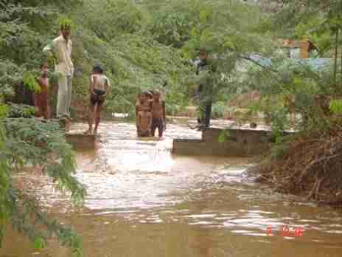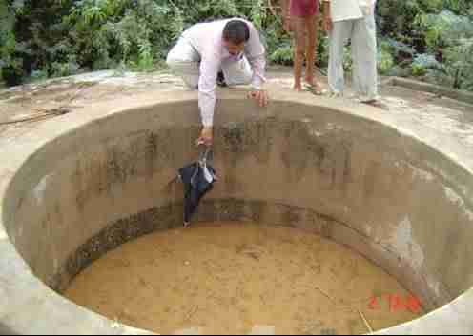
Water diverted to nearby abandoned well, through
an inverted filter and underground pipe
Figure 5: Ground-water Recharging through well in Ghaghas
Natural stream
Small masonry structure forces flowing water into wells
Recharge Well
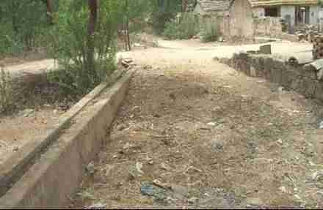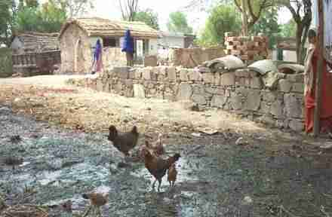
Figure 6 : Soak pit - a mechanism for safe disposal of waste water
BEFORE Soak Pit
AFTER Soak Pit
In village Agon, Ferozepur Jhirka Block

Underground structure of Soak pit
Cross-section of soak pit
Percolation
silt
trap
sand
brick bats/stones : size ¼ brick
brick bats/stones : size ½ brick
To Soak Pit
From Drain
Silt Trap
Sediments
Floating Scum
Figure 7 : Soak pit design
silt
trap

Soak Pits
Since May 2003, 200 soak pits have been constructed in 6 villages, out of which 56 are in Ghaghas. The other villages in rural Gurgaon are Rangala Rajpur, Karheda, Chehalka, Agon (Figure 6), Goela in rural Gurgaon.

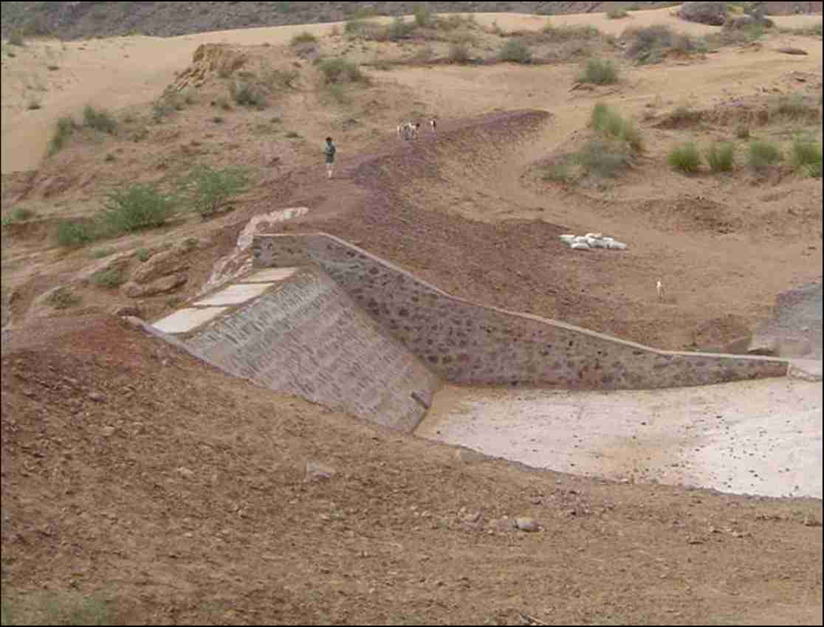
Figure 8 : Ghaghas Masonry Check Dam
Check Dam
Storage Basin
Desilting drain
Cushion Chamber to
protect the dam structure

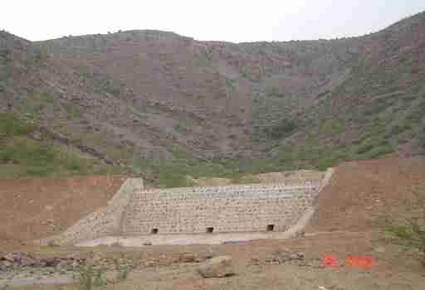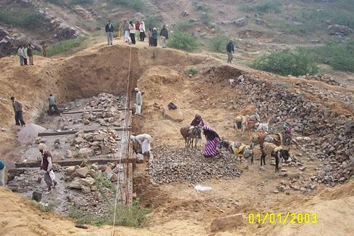
Under Construction
Masonry
Check dam
Aravali Hills
Completed
Silt Drains
Silt deposition site, when drains opened
Figure 9 : Silt Drains of Check dam

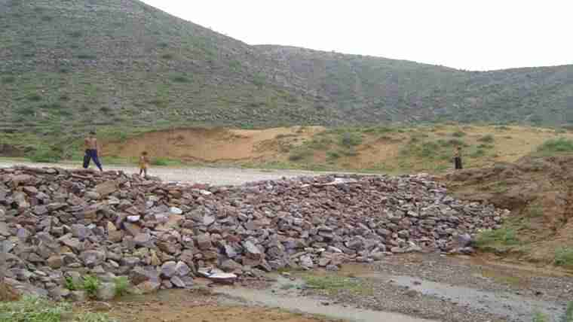
Sampling site – A
(Well)
1500 meters
from check dam
150 meters
from check dam
Check dam
Sampling site – B
(Hand pump)

Figure 10 : High nitrate & fluoride levels reduced due to check dam

Table 3: Change in ground water quality, due to check dam
Parts per million (ppm)
Parameter | Standard permissible Limits | Sampling Site - B |  |  | Sampling Site - A
Sampling on |  | Jun-03 | Dec-03 | Jun-04 | July-03 | Dec-03 | Jun-04
pH (units) | 6.5-8.5 | 8 | 8 | 8 | 8 | 8 | 8
Coliform | Nil | Nil | Nil | Nil | Present | Nil | Nil
Fluoride | 1 | 1.5 | 1.5 | 0.6 | 1.5 | 0.6 | 0.6
phosphorus | - | < 0.1 | < 0.1 | < 0.1 | - | < 0.1 | < 0.1
Nitrate as Nitrate | 45 | 100 | 100 | 10 | 100 | 10 | 10
Iron | 0.3 | 1 | 1 | 0.3 | 0.3 | < 0.3 | -
Hardness | 300-600 | 288 | 288 | 320 | 336 | 320 | 220
Chlorides | 250-1000 | 269 | 248 | 88.6 | 267.35 | 159.5 | 152.4
Ammonia | - | 0.2 | 0.2 | < 0.2 | 0.2 | < 0.2 | < 0.2
Turbidity (NTU) | 5 | 25 | 10 | < 10 | < 10 | < 10 | < 10

It took approx. 1 year for the dilution effects to to travel 1.5 km underground, indicating that horizontal movement of recharged water is a slow process.
Sample site A (150m away)

Sampling site B (1500m away)

Std. Permissible limits
Figure 11 : Improvement in Quality of Groundwater

The high concentration of nitrates and fluorides reduced to levels less than permissible limits, within a period of 6 months after the 2003 monsoon, at Site A. However for this effect to reach Site B it took another 6 months. In case of iron, in a period of one year the concentration reduced to zero at Site A, which is the permissible limit, whereas at Site B the concentration of iron is still 0.3 though it reduced from the baseline which was 1. These dilution results in one season of rain are encouraging and will continue further in successive seasons.
Jun.’03
Dec.’03
Feb.‘04
Jun.’04
Water
Depth to
reach water
Well
Ground Level
48ft
52ft
48ft
55ft
Additional
water
Figure 12 : Improvement in Ground Water Table

Figure 12, indicates that the quantity of ground water has increased in Ghaghas. A well was selected for the study of the ground water table. It had water at a depth of 55 feet from the ground, in June 2003 (prior to building of the check dam). After the monsoon the water level in the well rose by 7 feet and remained stable till February 2004. Then depleted by June 2004, but was still 4 feet higher than the baseline of the year before interventions. The terrain of the village area is such that the rain water used to flow out and hardly percolate, even if there was a good monsoon.
IV. Economics

Table 1 : Cost (Rupees) of Interventions to Sustain the Ground Water in Ghaghas
Time period : 2002 to 2004
Structures | Cost per unit | No. of Units | Sehgal Foundation  Contribution, per unit | Community Contribution, per unit  (may be labor) | Total
Reviving traditional structures* | 8,000 | 1 | 6,000 | 2,000 | 8,000
Check Dam in Ghaghas | 4,50,000 | 1 | 3,70,000 | 80,000 | 4,50,000
Well Recharging | 15,000 | 1 | 10,000 | 5,000 | 15,000
Roof Water Harvesting | 5,000 | 1 | 4,000 | 1,000 per unit | 5,000
Soak Pit | 150 | 56 | 50 per pit | 100 per pit | 8,400
Chizel (deep plowing) | 450 per acre | 60 acres | 150 | 300 | 27,000
Total Direct Cost |  |  |  |  | 5,05,400
Total Indirect Cost  (Sehgal Foundation’s institutional cost for water management program in Ghaghas) |  |  |  |  | 100,000
Grand Total = Rs 6,05,400
* Repair of an earthern embankment and its stabilization with vetiver grass.

Prior to the interventions, water level in the Ghaghas wells was depleting year by year. In a span of two years and a cost of about Rs 6,05,400 the ground water level here is sustained, both in terms of quantity (Figure 12) and quality (Table 1 and Figure 5).

Considering the likelihood of increased demand for water and possible failure of moonsons, two additional check dams and recharging wells are being planned.

Water literacy is an important component of the program and Ghaghas villagers have started installing and repairing taps to prevent wastage.

Table 2: Cost comparison of Filters versus Check dam in Ghaghas
Options | Cost in Rupees | Solves
Household models of Defluorination filters : Ion Exchange (India) Ltd. & Mytry | 4,50,000 capital + 60,000 annual maintenance | Only Fluorides
Check dam & other interventions | 5,08,000 | All contaminants & water depletion

V. Summary & Discussion
What worked in Ghaghas
- Involvement of the community during planning and getting their commitments in advance.
- High need for the intervention.
- The technical parameters for building the check dam were good for e.g. permeability of soil and basin area.
- Financial transparency won respect.
- Affordable costs and contributions.
- Consistent and regular communication by all staff members
Difficulties faced in Ghaghas
- Community contribution and collection happened only at the last minute for time-bound projects like check dams, which had to be built before onset of monsoon.
- The village task force in charge of supervising the construction was not up to mark in its involvement.
What would the Foundation do different
- Women would be involved more, particularly for supervision of projects. They are more sincere and take more pride in community work
- Before starting the projects, the Foundation would spend more time with all sections of community including school children and youth on Water Literacy, through a curriculum.
- Village communication would be improved using proven IEC tools like newsletter to inform of project progress and acknowledge role models.
- Even if it means slowing down the work, the Foundation would limit its assistance to only a technical advisory role and joint financial management. Thus villagers would handle the projects much more independently from the beginning itself in supervising the work, procuring material and organizing labor.

Sustainability of Water Management in Ghaghas
Right from the beginning, Sehgal Foundation facilitates discussions on the urgency of taking development into ones own hands, talks of the partnership mode of working and declares that its hand-holding would be only for 4 years, within which period sustainability has to be achieved.

An Executive Committee member of the Village Level Institution becomes in-charge of water management. For all the work, labour is from the village, so the people automatically get trained and their confidence increases. Selected individuals are provided training on maintenance. ‘Who is in-charge of what’, is well-communicated within the village.

Some panchayat members are part of the Village Level Institution and Sarpanch is an automatic nominee. Thus whenever possible synergies will be made using Government funds.

VI. Conclusion
This paper highlights ways in which ground water can be managed. When the community participates and has to contribute financially, there is pressure to innovate. Lot of credit goes to a few progressive villagers who are willing to try out new things and subsequently become demonstrators for others. The Foundation’s model depends a lot on volunteerism in the village and believes that further research on this is needed.

The Foundation uses the principle that ‘success builds success’, and focuses on small interventions which can make big impact. When the Foundation came to Ghaghas about 1.5 years ago, there was much resignation, however in a relatively short time this has got converted to enthusiasm after the villagers saw the water filling up in the check dam and percolating into the ground ten times, during the intermittent monsoon showers. The Foundation believes that rural development need not be as expensive as often perceived and trust building need not be too time consuming either, if the organization walks-its-talk and plans properly in terms of benchmarks, timelines and deliverables. Though the Foundation has had its share of problems both technically and in community mobilization, in general the villagers’ patience, trust and welcome has been rewarding.

VII. References
1. Village Ghaghas is in Nagina Block, Gurgaon District. This is the Mewat region of Gurgaon, populated predominantly by Meo-muslims. The social indicators of Mewat region are low. The population of this village is about 2000 people i.e. 300 families.

2. The Bureau of Indian Standards: WHO guidelines on water quality, (desirable and permissible limits of substances(contaminants))
(a)http://www.webhealthcentre.com/expertspeak/indianstandards.asp
(b)http://www.webhealthcentre.com/expertspeak/indianstandards.asp

3. Sulabh International, Delhi

Acknowledgements
- We thank the Ghaghas Village Level Institution – ‘Kala Pahar Gram Vikas Sanstha’, for making it happen.
- The contribution of Mr. B.R. Poonia, Program Leader - Community Mobilization is highly acknowledged.
- We gratefully acknowledge the commitment and hard work of Shri Goverdhan, Shri Mahipal and Mohamed Zafer of Sehgal Foundation’s Program Implementation Team.
- We thank for their guidance and sincere interest, Dr. Rakesh Pandey and Ms. Sunita Chaudhary, N.M. Sadguru Foundation, Gujarat; AVM Sahni, Developmental Alternatives, Delhi; Dr. S. Wani, ICRISAT, Hyderabad

Resume of Author
Lalit Mohan Sharma is Program leader Water Management and Infrastructure Building of Sehgal Foundation, India. He is a graduate civil engineer and holds a Masters of Technology (management & systems) degree from Indian Institute of Technology, Delhi. He holds a post graduate diploma in Construction Management and is a Fellow of the Institution of Values. Prior to joining the Foundation, he was the Manager Infrastructure Development at Proagro Group of Companies, now a Bayer Company.

* For Correspondence. Email: lalit.sharma@smsfoundation.org
Website: www.smsfoundation.org, annual reports are posted
High level of nitrates is due to agricultural chemicals.
High level of fluorides is due to concentration of natural fluorides because of depleting water quantity.
Filters and water treatments have prohibitive costs for villagers, not easily available, address only a few toxins and their adoption in each household cannot be ensured.
The water in recharging wells cannot be used for drinking or domestic purpose, it effectively percolates to the ground water table and gets naturally filtered by the soil to become usable.
Injecting wells are bored into the ground, have an inverted filter and a perforated pipe leading into the ground to recharge the water table
Village Level Institution is a local peoples’ association, inspired by the Foundation, which is dedicated to the benefit of the whole community, based on the needs of the people, and is impartial to the socio-religious-economic dynamics of the village. The Panchayat also works for village development but is a political body and is mostly handed down funds for highly specific actions, as decided by the higher Government authorities, often without consulting the local people.
A Village Champion is a respected local person with leadership qualities, who acts as a development cheer leader and has natural altruism in her/his personality to work for the benefit of the whole village.
The filter pit is first filled with the largest sized stones or brick pieces, the middle layer has medium sized stones or brick pieces and the upper layer closest to the ground has sand (Figure 6).

